CS590BD Big Data Analytics and Apps

**LAB - 2**

**Report on collecting data from sensor tags**

**and pushing the collected data into HBase**

**By**

**Ponnam Balakrishna**

**16177831(BP8G6)**

**Collecting data from the sensor tag and pushing that data into HBase:**

To collect the data we have many devices and I have chosen sensor tag to collect the data. From this sensor tag I am collecting Longitude, Latitude, Humidity, Pressure and accelerometer values like X, Y and Z.

To collect this data we need to follows some steps those are:

**Step1:**

Install the **BLE Sensor tag** App in android mobile having the OS higher than 4.3 versions.

Then run the App and Switch ON the sensor button .The App shows the sensor devices which are available.

The below screen shows the devices which are connected:

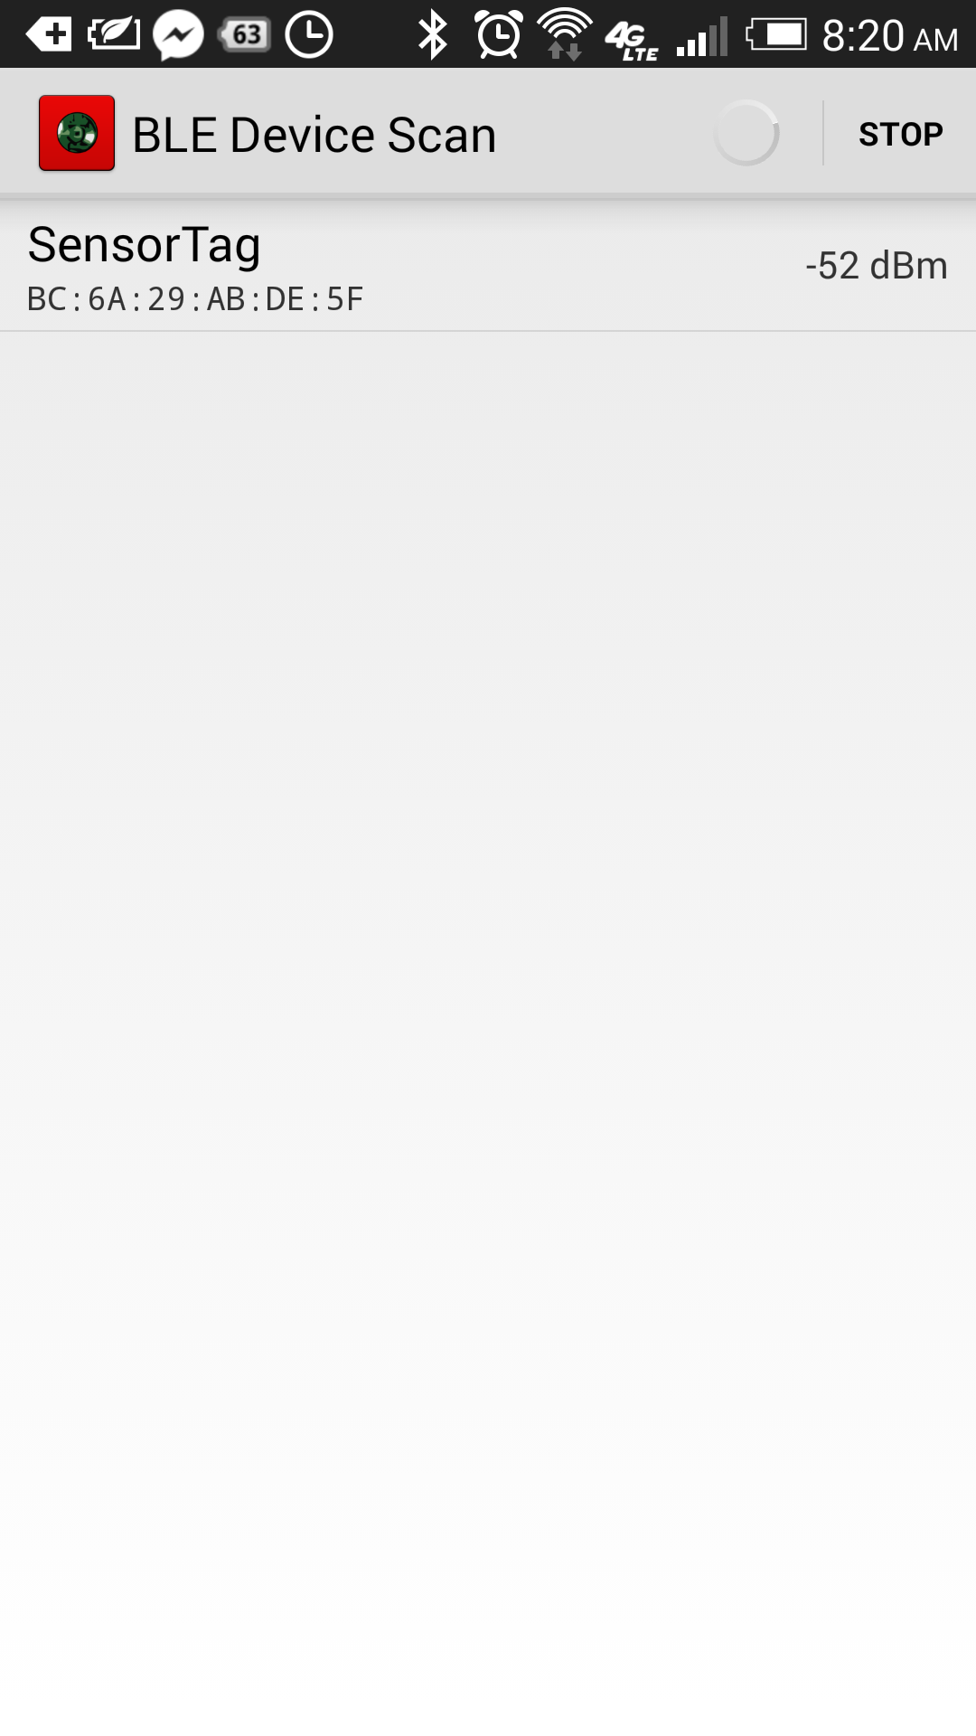

**Step2:**

Those list all the connected devices. If we select any connected device from the shown list it displays all the list of services available. It shows all the list of services provided by this sensor those some of the services we are using are GPS which gives the longitude, latitude, Pressure, Humidity and the accelerometer values which is indicated in the terms of X,Y and Z. By selecting any list of the service we get some sub list of services which we are required for collecting the values.

The below screen shot shows the list of services provided by this sensor

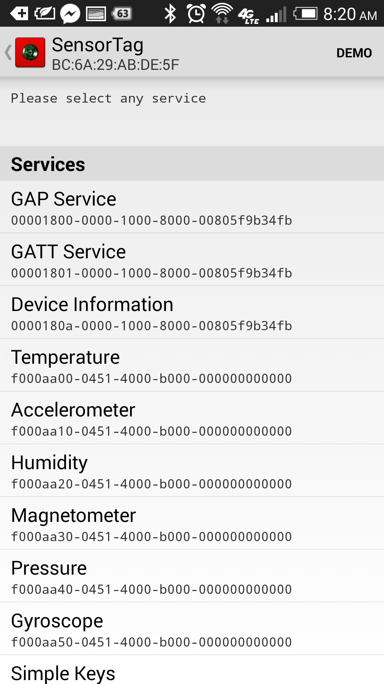

By selecting any of these devices it open some of the sub tasks and by selecting those it gives the values of the particular selected item.

For collecting the particular data we need to enable the service tags of the particular services in the Android application.

**Step3:**

Run the android application and enable those services and their UUID tags. So that it collects the data of the enable UUID tags.

Those enabled and collected data is stored in a text document which can be getting by downloading **ASTRO FILE MANAGER APP** where the data is present in the Data folder of the ASTRO FILE MANAGER APP.

The below screen shot shows all the services UUID tags:

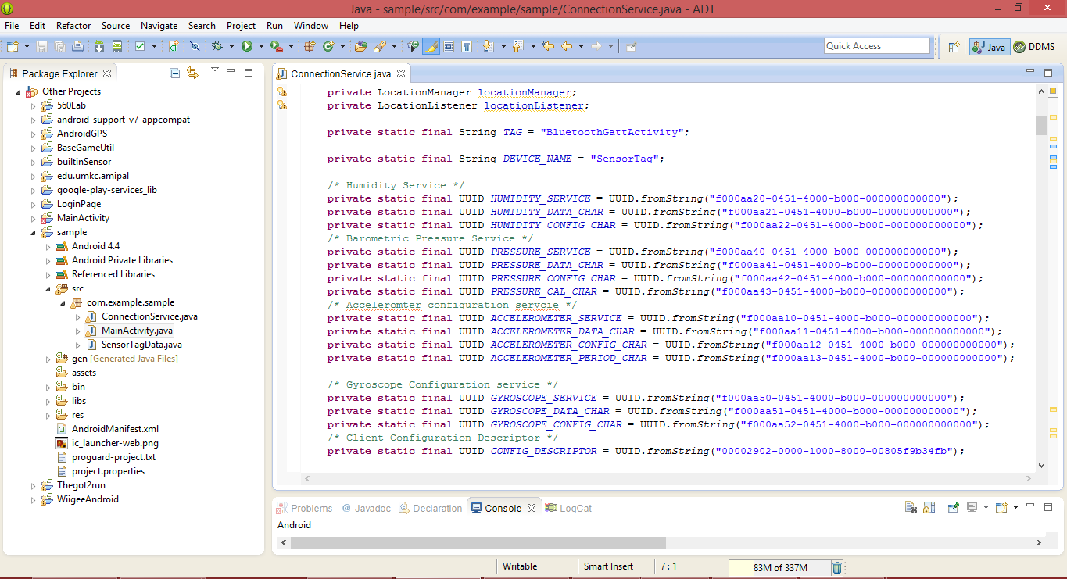

The below screen shot shows the different cases where the program enters each loop and collect the required data of the particular service.

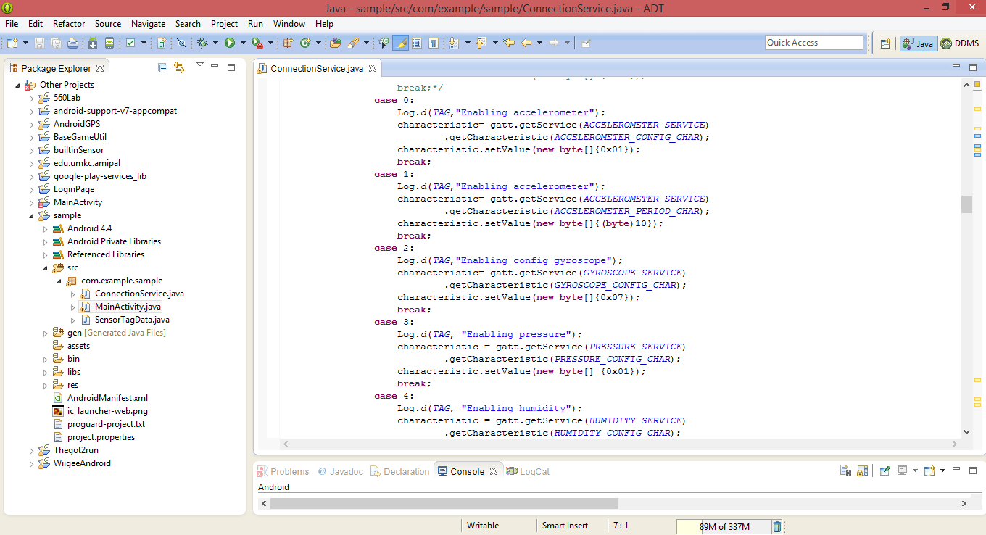

In those the program enters into the particular case where if the particular case of the service is available.

And it shows all the collected data in the log file. It collects all the data of which service is enabled.

The below screen shot shows the Log File of data collecting the accelerometer values indicating as X,Y and Z.

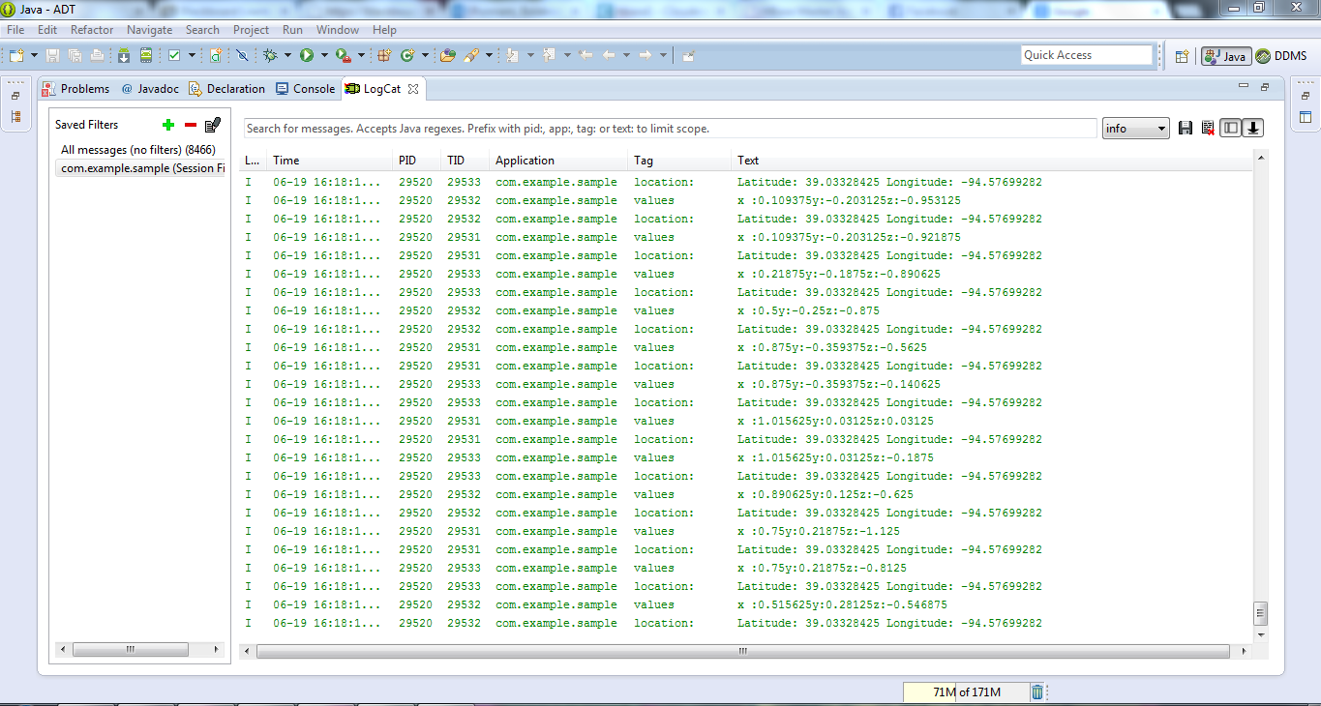

Those collected data is stored in the Astro file Manger under the Data folder. It is a text document containing all the collected data of the enabled services.

**Step4:**

The data is collected in this text document which needs to run on a java program to insert into the HBase.

The below screen shows the collected data from the sensor given with the tab spaces for each value

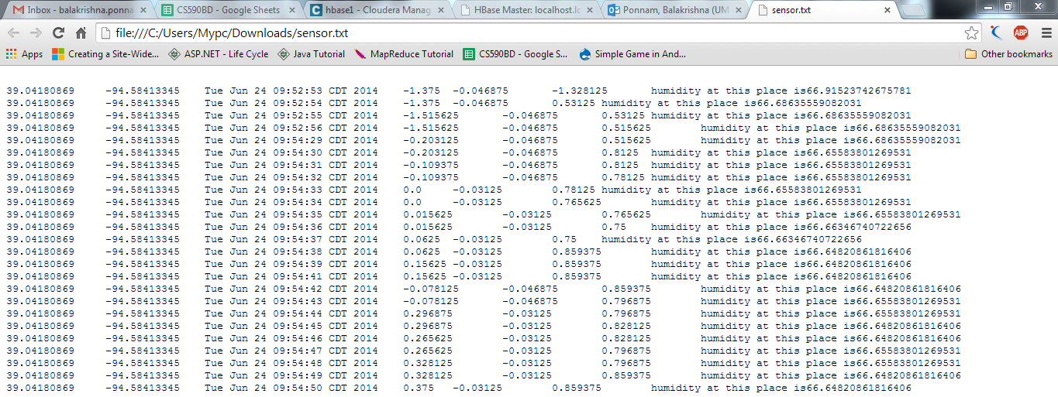

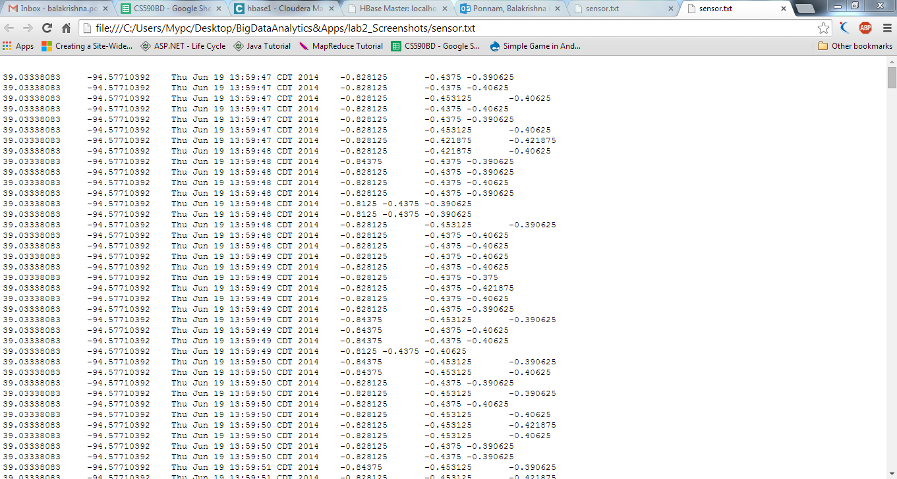

**Step5:**

**Inserting into HBase:**

We had written code in java for

* Creating the table in HBase.
* Inserting Collected Data into the created table in HBase.
* Retrieving the collected data from the table.
* Deleting the table Created in the HBase.

By executing the function to create a table the table is created.

The below screenshot is the creation of new table at run time:

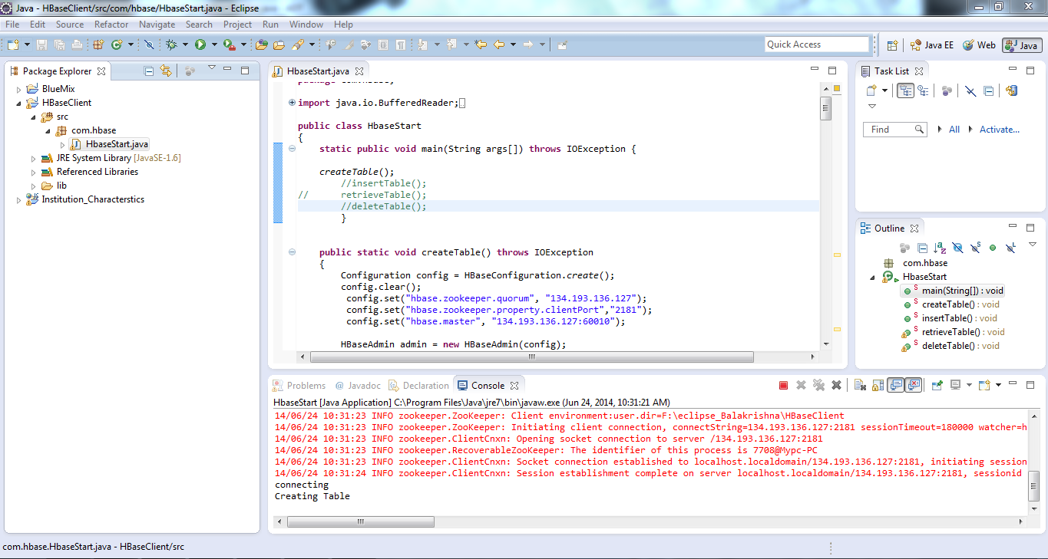

The above screen shot is at the time of creation of table at run time where you can see the message saying creating table.

The below screen shot shows that the creation of table is done. Where we can observe in the console

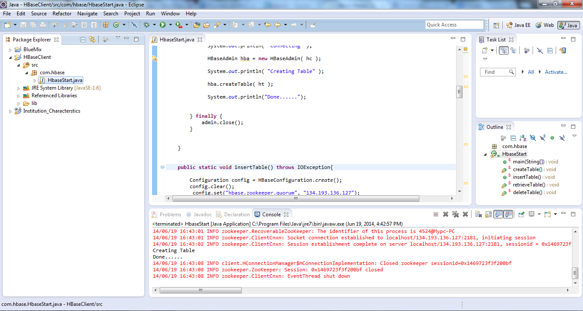

And then to insert the data we need to specify in the code where the data is located. We need to specify the path of data to get uploaded.

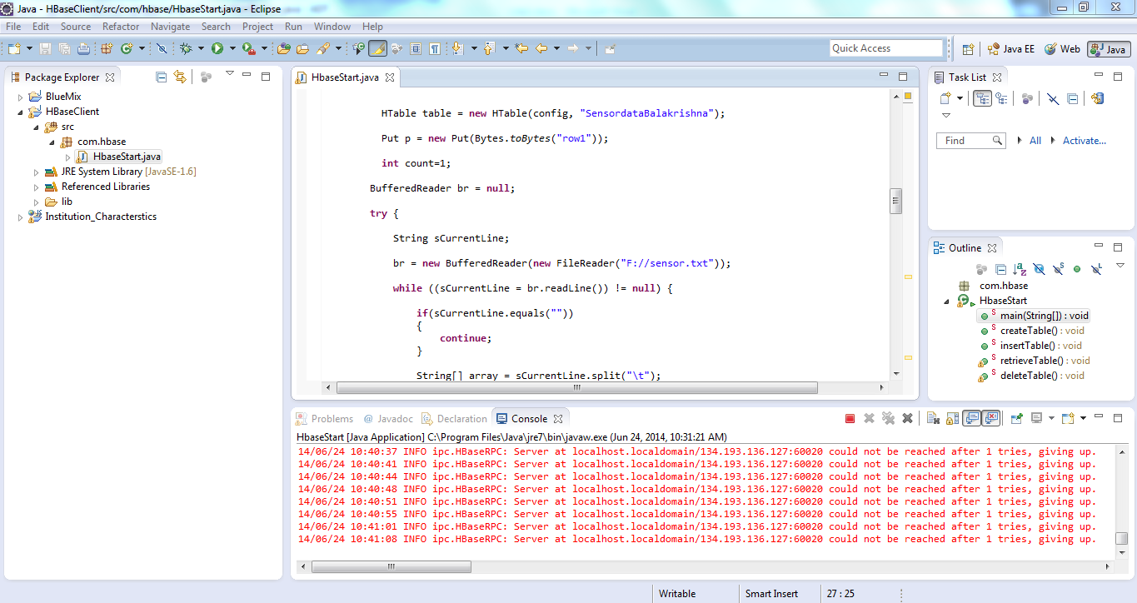

In the above screen it is mentioned as Sensor.txt in F drive so the path is given where the data is located.

Then we need to remove the code of creating the table and run the insertion function with the same table name. Where the data will be inserted in that particular table

Similarly we can retrieve the data from the table and can also delete the table.

Below is the screen shot of the created table showing in the UI of HBase

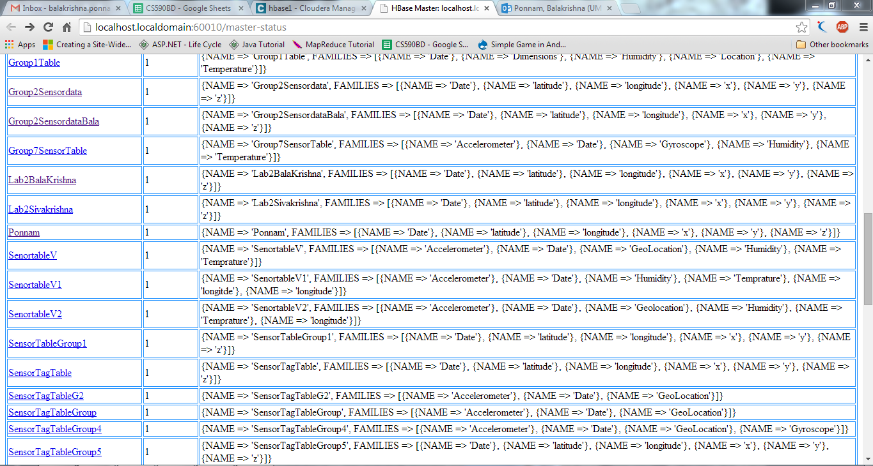

Thus the retrieving of data screen shot is as follows:

